Annexure II

LIST OF PUBLICATIONS OF DR. D.B. BORALKAR
1. Factors affecting the proteolysis of cytoplasmic protein, Marathi Univ.
J. o Sc. (Nat. Sci.) XVIII Sc. II, 25-28, 1979.
2. Effects of gaseous ammonia on plant growth an production. Ind. J. Air Pollution Control, 2(1); 19-23, 1979.
3. Sulphur dioxide effects on Jowar, Saghum vulgare, Pers. var. CSH-1, Proc. Symp. on Environ. Bio. 361 – 366, 1979.
4. Plants for air monitoring in industrial areas in Furtado. J.I. (Ed.) Tropical Ecology an Development pp. 669 – 675, 1980. I.S.T.E. Kuala Lampur.
5. A closed chamber for exposing plants to air pollutants. Ind. J. Air Pollution Control, 3(1): 23 – 26, 1980.
6. Effects of industrial air pollutants on plants. Reports of the research work done on the U.G.C. sponsored project, 1980.
7. Studio of the Krishna river ecosystem between Karad and Sangli (Maharashtra State). Report of the research project done, Jul.– Dec., 1980.
8. Effects of sulphur dioxide on Sunnhemp, Crotalaria juncea, L. Geobios, 8(5): 236 – 237, 1981.
9. Studies on salt build up in the Krishna River, Maharashtra State. Acta Limnol. Indica. 1(1): 5 – 9, 1981.
10. Studies of the soil pollution along the Krishna river in the State of Maharashtra.
J. Environ. Bio. 3(3), 113 – 117, 1982.
11. Effects of sulphur dioxide and ozone, singly an in combination, on germination and chlorophyll of Abelmoschus esculemtus var. Pusa Savni. J. Environ. Biol., 4(3): 99 – 102, 1983.
12. Foilar injury to Trigonella Foenum-graecum L. due to sulphur dioxide exposure. Ind. J. Air Pollution Control, 5(3): 24 – 26, 1983
13. Effects of ozone and sulphur dioxide alone and in combination on seed germination. Ind. J. Air Pollution Control, 4(4): 46-47, 1983.
14. A report on the environmental damage due to lethal chemical catastrophe in Bhopal, December 1984. Publication of Central Pollution Control Board, New Delhi; PROBES/31.
15. Increase of lead concentration in ambient air during the IX Asian Games 1982 as indicated by the plants. Ind. J. Air Pollution Control 7(2):
65-73, 1986.
16. Impact of auto-exhaust lead pollution on vegetation in U.T. of Delhi. Publication of Central Pollution Control Board, New Delhi, No.EIAS/1/1985-86.
17. Impact of auto-exhaust lead pollution on vegetation in U.T. Delhi. Publication of Central Pollution Control Board, New Delhi, No.EIAS/2/1985-86.
18. Nature of sensitivity of plant species to sulphur dioxide. Geobios 19 (2-3) 110 – 116, 1989.
19. Effects of atmospheric pollution due to a glass industry on plants in Karad (Maharashtra). Res. J. Plant & Environ. 5(2), 11–14, 1989.
20. On the sampling and analysis of lead content of atmospheric particulates by atomic absorption spectrophotometry. Proc. Seminar on “Pollution Monitoring an Control Technology” by Grammya Research Analysis Institute, Baroda, August, 1989. Report No.GRAI/TR – 8938.
21. Auto-exhaust lead pollution of roadside ecosystem in Delhi (Part II). Proc. Int. Conference on Environment Planning & Management, University of Roorkee (India), April 5-7, 1990, pp. 204 – 210.
22. Use of Alfalfa plants or the ambient air quality monitoring in the city of Delhi. Geobios. 18(1): 29-32, 1991.
23. Autoexhaust lead pollution of roadside ecosystem in Delhi J. Ind. Asso. Environ. Mgmt. 19, 21-27,1992.
24. Multidisciplinary approach to air quality monitoring. J. Inst. Pub. Hlth. Engr. India,: 56-62, 1993.
25. A review of fluoride pollution effects studies in India. ENCOLOGY, 9(4): 1-5, 1994.
26. Suggested guidelines for green belts in industrial area. ENCOLOGY, 9(7): 21-25, 1994.
27. Experience in implementation of environmental standards in lead industry. Proc. workshop Lead Pollution-Control & Monitoring, ILZIC & CPCB, New Delhi, August, 1995. Appeared in “Ecology in Practice” – a collection of Articles for Prof. S.B. Chaphekar’s festschrift volume on his 60th birthday edited by C.S. Latto of Prof. S.B. Chaphekar Felicitation Committee, Bombay, in November, 1995.
27-A. Suggested protocol on survey and preparation of waste management plan for industrial estate. Encology, 10 (8), 8-12, January, 1996.
28. Guidelines for setting up of operating facility: Hazardous Waste Management, Publication of CPCB No.HAZWAMS/11/1998-1999.
29. Ready Reckoner: Hazardous Waste Management, Publication of CPCB No. HAZWAMS/ 12 /1998-1999.
30. Experimentation on bio degradation of detergents by OECD-301 B Method [Modified Strum Method] J. Microb. World: 2 (1) pp.49-58, 2000
31. Recovery and recycling of secondary lead and its waste disposal in India. Poster Presentation at the 6th World Congress on Integrated Resources Management, held at Geneva (Switzerland), February 12-15, 2002.
32. Reprocessing of secondary zinc and environmentally sound management of wastes in India. Paper accepted for Oral Presentation in the 6th World Congress on Integrated Resources Management, held at Geneva (Switzerland), February 12-15, 2002
- Approach paper on Air Pollution Control Strategies for Mumbai. High Level Conference on Air Pollution Control Strategies for Mumbai, March 1-2, 2005
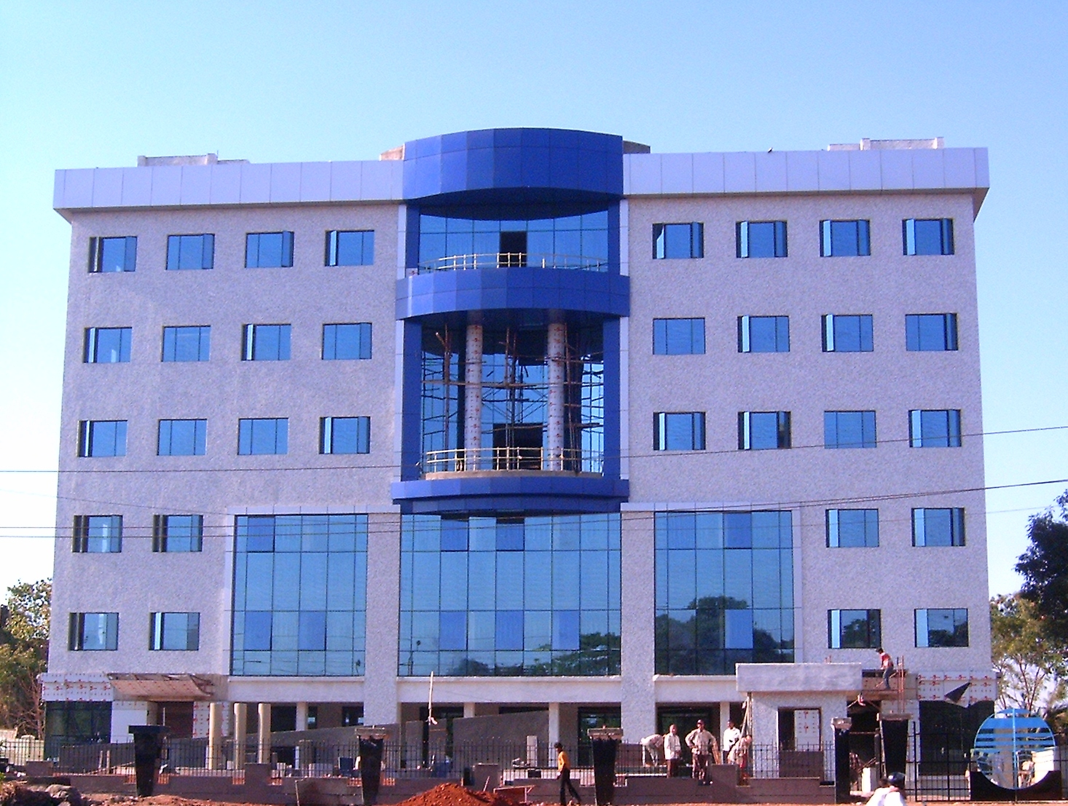
- Air Quality Management Needs of Urban Centers in India. Roundtable on Policy Instruments for Air Quality Improvement in in South Asian Cities", New Delhi, May 13-14, 2005
- Initiative of Air Pollution Control in India. Urban Air Quality Forum, AWMA Conference, Minneapolis, USA, June 22-24, 2005
- Policy of Interventions for Air Pollution Control in Mumbai : Cost Benefit and Perspective of India’s 25 years of Air Act Implementation. Better Air Quality International Conference, Jakarta, 2006
- An Integrated Approach to Understand Economics of Air Pollution Effects on Plants" Better Air Quality International Conference, Jakarta, 2006
- Trends of Air Pollution in Mumbai: Multi-Statistical Approach. Environmental Monitoring and Assessment, Kluver Publisher, Accepted for publication 2006
- The Environmental Benefits Mapping and Analysis Program (BenMAP) - A Demonstration Case Study Involving Air Quality Planning in Mumbai, India
- The Environmental Benefits Mapping and Analysis Program (BenMAP) - A Demonstration Case Study Involving Air Quality Planning in Mumbai, India. Better Air Quality International Conference, Jakarta, 2006
- Report on BENMAP Application for Mumbai. Prepared jointly with US-EPA,NEERI, MPCB and ABT Associates., 2006
- Pune Source Apportionment Study and Air Quality Management : Compendium Publication : Online CAI-Asia website:http://www.cleanairnet.org/caiasia/1412/article-60420
- Benefit Mapping of Air Pollution Control in Mumbai (BENMAP): Compendium Publication. Website: http://www.cleanairnet.org/caiasia/1412/article-60422 : Online CAI-Asia Website
- Policy of Interventions for Air Pollution Control in Mumbai: Cost Benefit and Perspective of India’s 25 years of Air Act Implementation. Paper accepted for presentation by Air and Waste Management Association at St. Pittsburg.
- A profile on Waste Minimisation and Recycling in Chemical Process Industry. Paper presented at Symposium on Chemistry in Societal and Environmental Needs organized by Madras Science Foundation and Center for International Cooperation in Science, held at Central Leather Research Institute, Chennai, August, 2011

(Dr. D.B. Boralkar)

